IN LOVING MEMORY  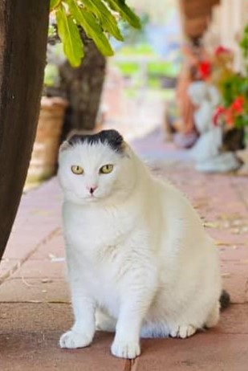  SULA  circa 2005 – AUGUST 24, 2022  PAX ET BONUM | Prayer of St. Francis  Make me an instrument of your peace.  Where there is hatred, let me sow love.  Where there is injury, pardon,  Where there is doubt, faith,  Where there is despair, hope,  Where there is darkness, light,  And where there is sadness, joy.  Lord, may I not so much seek  So much to be consoled as to console,  To be understood as to understand,  To be loved, as to love.  Because it is in giving that we receive,  In pardoning that we are pardoned,  And it’s in dying that we are born to eternal life. Amen.

