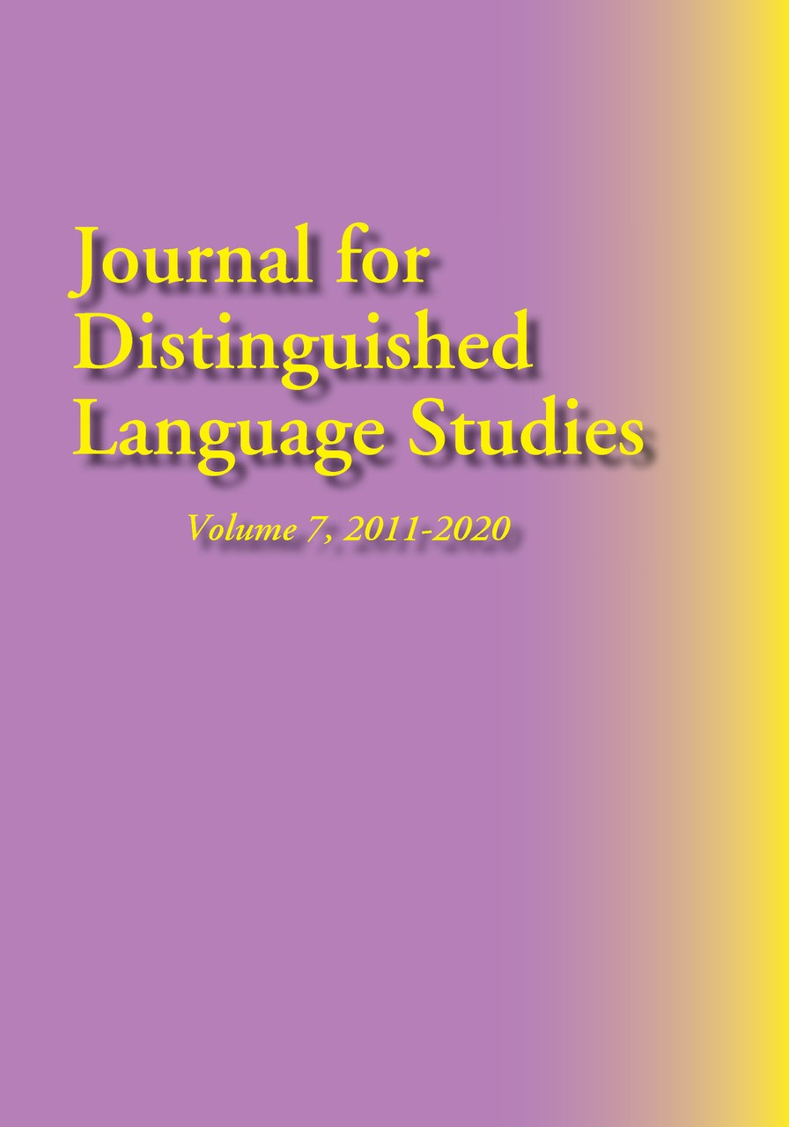
We are working on making this journal more interactive, including a planned html version. Items in bold, if not currently available by clicking, will be available soon. Please check back from time to time for accessibility to abstracts and articles. (Abstracts and book reviews are provided free of charge. Articles may be purchased through the MSI Press webstore as downloads for $5.)
The full journal in paperback may be purchased from the MSI Press webstore; libraries are encouraged to query about subscriptions for both paperback and e-copies. The latter should be available soon.).
Table of Contents
Editors' Note
Personal Experience: How I Achieved Near-Native Fluency in Russian (Dr, William Hopkins, US Government Interpreter)
Feature Articles
Glancing Backward, Looking Forward: The History of the "Level 4 Movement" and the Journal for Distinguished Language Studies (Dr. Betty Lou Leaver)
Rethinking the Rating Process Solution to the Threshold Performance Dilemma (Dr. Mary Jo DiBiase-Lubrano & Jana Vasilj-Begovic) (available for free download from the JDLS webpage – see Volume 7, sample article)
Re-Conceptualizing Language Programs to Achieve Level 4 (Dr. Christine Campbell)
To Superior and Beyond: Developing Professional-Level Proficiency in a Fourth-Year Russian Program (Dr. Tony Brown, Dr. Jennifer Bown, Dr. Katya Jordan, & Dr. Elizaveta Kurganova)
The Challenge of the Inverted Pyramid in Attaining Distinguished-Level Proficiency (Dr. Andrew Corin)
Feature Article Contributors
Abstracts (available for free download from the JDLS webpage)
Arabic (online only - see below)
Chinese
French
Russian
Spanish
Book Review
Dictionary of Advanced Russian Usage by Michael Kayser (reviewed by Jack Franke)
General Information
Books about distinguished language proficiency published 2011-2020
Call for papers

