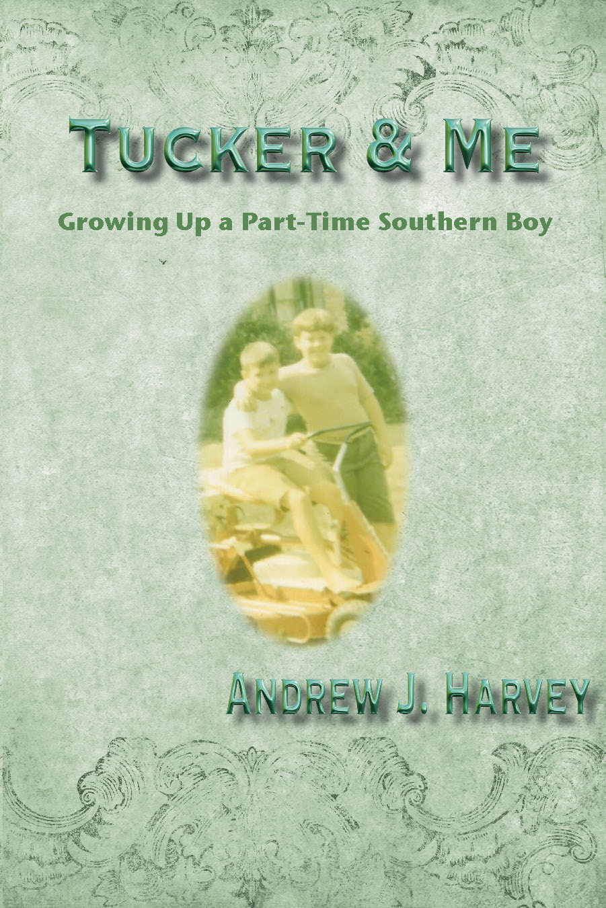  Tucker & Me: Growing Up a Part-Time Southern Boy  by  Andrew J. Harvey  MSI Press  ISBN 978-1942891857  Non-Fiction:  Memoir  Regional: South  $19.95  On sale at www.amazon.com, www.bn.com,  and select book retailers  December 1, 2017  Order direct from MSI Press: orders@msipress.com  For more information  or to contact the author for media commentary, email editor@msipress.com. | FOR IMMEDIATE RELEASE  Contact: Betty Leaver, Managing Editor, MSI Press  1760-F Airline Hwy, Hollister, CA 95023  831-578-0290 (phone); 831-886-2486 (fax)  editor@msipress.com  Tucker & Me: Growing Up a Part-Time Southern Boy  A memoir with the taste of childhood and the flavor of the South.  “A friend of mine, who knows me only as an adult, is convinced that as a young boy, I must have been like the son represented in the movie Problem Child. For those unfamiliar with this film, the young boy had a light complexion, along with red hair, both of which were the case with me when I was a child. The boy had adult-like characteristics, coupled with somewhat of a deviant side. He was extremely capable at outsmarting the adults, something he utterly relished doing. I think my friend may have had me pegged pretty well, despite having not known me when I was young.  I always felt like I was a small adult instead of a child. Unfortunately, with the sole exception of my brother, no one caught on to this and treated me accordingly. Instead, they acted as if I was a more typical child, which led to all kinds of problems for both them and me. I’ve heard people referred to as an ‘old soul,’ and I think this is how I was always wired.”  -excerpt from Tucker & Me  The story of a child growing up in the Mad Men era of the 1960’s, Tucker & Me is filled with humor, sadness, and harrowing incidents, the memoir reflects all the emotions of life one experiences growing up, in this case, with a single mom who lived in Los Angeles and a father who lived in a small-town suburb of Atlanta, Georgia known as Tucker. Traveling in the summers to the alternate universe in Tucker, the author experienced a roller coaster ride of two completely different lifestyles.  Praise for Tucker & Me has focused on:  - the powerful re-creation of two very different worlds and the way in which they are skillfully merged in the telling of the tale of a child who grew up in both;  - the simplicity of the tale-telling that will touch anyone who reads the book;  - the warmth and friendliness—and openness and frankness—oozing through the author’s descriptions;  - The uncanny ability of the author to truly capture the essence of the South; and  - The everyman feel to the author’s experiences that leads the reader to relive his or her own childhood through the pages of this book.  “Readers can feel and taste the magical moments. You feel like you’re sitting by the fireplace with Uncle Andy, sipping coffee and listening to his fanciful yarns.”  - J. Bennett Easterling, author of award-winning Of God, Rattlesnakes, and Okra  # # #  Dr. Andrew Harvey is an award-winning college educator with experience, ranging from community college to university doctoral level. He holds an educational doctorate in the field of organizational leadership from Pepperdine University and bachelor’s and master’s degrees in criminal justice from California State University at Los Angeles. He served in law enforcement for 25 years, retiring as a captain.

