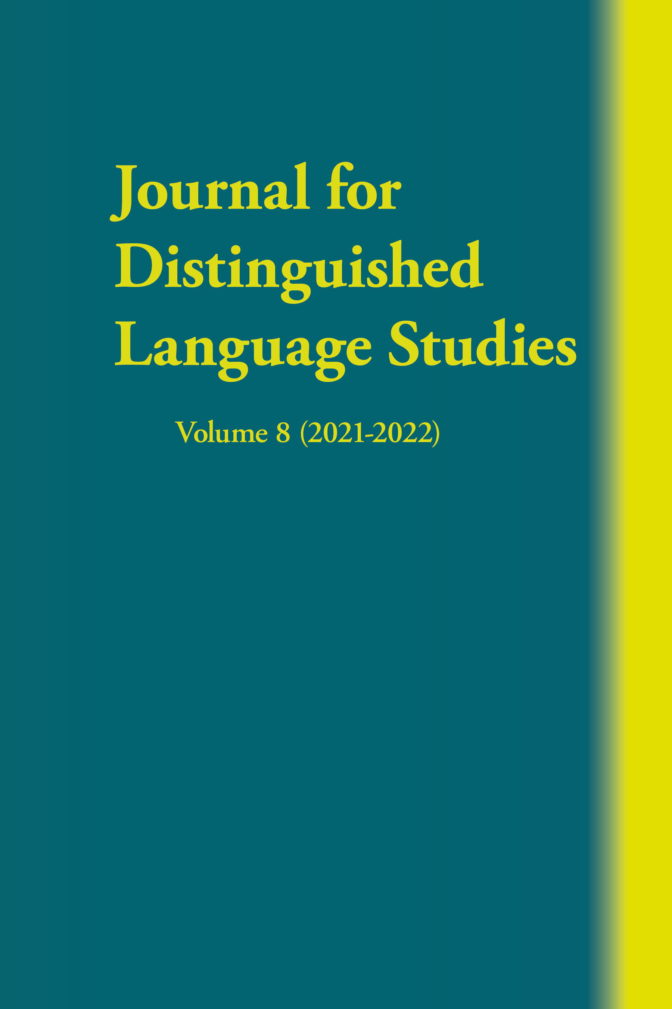  Journal for Distinguished Language Studies  Volume 8  (2021-2022)  ISSN  1547-7819  ISBN  9781950328856  Nonfiction  Language Learning  $39.95 paper  Release date:  August 26, 2023  Journal available at  Amazon  and  Barnes & Noble  individual articles  for sale at  www.msipress.com/shop  more information:  www.msipress.com/journal-for-distinguished-language-studies  media: contact editor@msipress.com  subscriptions: contact  orders@msipress.com  or  www.msipress.com/shop | FOR IMMEDIATE RELEASE  Contact: Betty Leaver, Managing Editor, MSI Press  1760-F Airline Hwy, Hollister, CA 95023  831-578-0290 (phone); 831-886-2486 (fax)  editor@msipress.com  Journal for Distinguished Language Studies, Volume 8  The purpose of the Journal for Distinguished Language Studies is to provide a forum for exchanging information about teaching to and reaching near-native foreign language proficiency for teachers, learners, and professional language users. Areas of interest include research, theory, and practical application.  Currently, the JDLS is published biennially. From 2003-2010, it was published by the Coalition of Distinguished Language Centers, which closed in 2010. Since 2011, the journal has been published by MSI Press LLC in Hollister, California.  Always cutting-edge and containing experience and research unavailable mostly anywhere else about teaching and learning at such high levels of foreign language proficiency, articles in Volume 8 present personal experience, teaching experience, and research in academia and at government Institutions in the USA and France, and includes a range of foreign languages: Chinese, English, Russian, Spanish (including heritage Spanish), and formative assessment that can be used with any foreign language. Five books on high-level-proficiency topics are reviewed.  The eighth volume of the JDLS contains the following articles:  How I Attained “Near-Native” Proficiency in Chinese (Cornelius C. Kubler, Williams College)  Beyond the Language: Debating as High-Intensity Cultural Engagement & Leadership (Emilie Cleret, French War College)  Helping Learners Achieve the Distinguished Level of Proficiency (James E. Bernhardt, Foreign Service Institute)  Roadmaps to Distinguished Speaking Proficiency (Jack Franke, Defense Language Institute Foreign Language Center)  On the Cusp: Zone of Proximal Development Tables to Guide Formative Assessment (Betty Lou Leaver, MSI Press LLC)  Protocol-Based Formative Assessment: Evolution and Revolution at the Defense Language Institute Foreign Language Center (Andrew R. Corin & Sergey Entis, Defense Language Institute Foreign Language Center)  The following books are reviewed:  (1) Lessons from Exceptional Language Learners Who Have Achieved Native like Proficiency: Motivation, Cognition, and Identity by Zoltán Dörnyei and Katarina Mentzelopoulos, reviewed by Natalia Lord, (2) Mastering Italian through Global Debate by Marie Bertola and Sandra Carletti, reviewed by Alessandra Rice and Francesca Gasparella, (3) Mastering Spanish through Global Debate by Nieves Pérez Knapp, Krishuana Hines-Gaither, and Morella Ruscitti-Tovar, reviewed by Joseph Fees, (4) Stories from Exceptional Language Learners Who Have Achieved Nativelike Proficiency by Katarina Mentzelopoulos and Zoltán Dörnyei with Capucine Trotignon, reviewed by Thomas Jesús Garza and (5) Practices That Work: Bringing Learners to Professional Proficiency in World Languages, edited by Thomas Jesús Garza, reviewed by Michael Wei.  CFP, Volume 9 (2023-2024): JDLS - MSI Press MSI Press

