I Am Not Alone
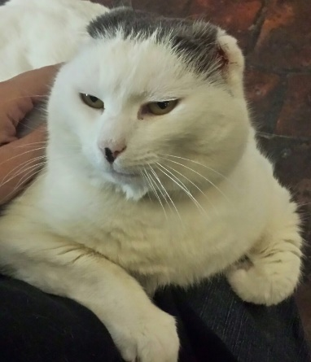
Photo by Kaleena Scargill
Some of the people who form a big part of my mission struggle with cancer. I do understand them—their fears, their pain, their sometimes-sadness. I feel those things, too, at least as much as a cat can feel. I know that God made humans to have even deeper feelings and a greater range of feelings, and I am glad that some of those feelings include loving animals because it is through that love that I can connect with them and bring them the message of God’s love.
I have to tell you about one of my special friends, Loryn. She understands me because she had cancer, and I understand her because I had cancer—the same way Cody and I understand, support, and love each other.
Maybe it is better if I am not the one to tell her story, though. Maybe she should tell her own story. I think you will find it more interesting that way. So, here is what she wrote for my book about her experience:
Over seven years ago, I had a malignant melanoma on my face. It was enough of a significant and serious depth to require the surgeons to remove a great deal of my face and use a flap to repair it. Needless to say, it left a visible scar on my face resembling a large train track. Both my beloved father and a dear friend and co-worker had died recently as a result of melanoma. I was so grateful to be alive. Each day was a gift. I have never been a beauty queen so I tried to be grateful for life and to hell with vanity. At least that is what I told myself. The trouble was each time I saw the scar or someone mentioned it, all the fear and pain would all come back.
It was a bitterly cold evening right before Christmas. I had just moved back to California. I was so happy to be back home, for good. My husband and I had invited some elderly friends from an assisted living facility for a pre-Christmas dinner. I and the wife of one of our guests attended 5:00 Mass at the Mission. I had noticed Sula before happily cuddling on different people’s lap’s .I was always so jealous. I adore animals and I was so impressed that she was in the Church. I never had her pay much attention to me before. It didn’t matter I was just so happy she was in the Church. That bitterly cold night was different. She made a beeline for my lap and stuck to me like a postage stamp. She was so quiet and comfortable; I didn’t have the heart to get up when the priest processed down the aisle at the end of Mass. Father kindly smiled and commented on how happy she looked in my lap .I was so happy to have her company. I knew in a very deep way that it was a special gift.
After Mass we joined my husband and two elderly gentlemen at the old German restaurant on Third St. One of the gentlemen was a World War II veteran. My father had also been in the Navy and fought in World War ii so I always enjoyed reminisces about the War. Little did I know that after a few glasses of wine this man’s conversation would get loud and ugly.
In a voice heard throughout the small restaurant, he pronounced, “I have seen Navy pilots injured like you with huge scars. They all looked 100 % better than you do. What kind of doctor did you have, anyway?”
All the angst and fear came rushing back. All I could think of was being alive despite the cost.
I mumbled, “I guess I am just glad to be alive.”
We all have our scars; some more prominent than others. Sula had her little ears removed due to cancer. We are still here. We can still love. Thanks to her, what could have been a terrible memory is tempered by the warmth and comfort she brought me on that horribly cold evening.
I empathize with Loryn. People who know me accept me as I am, but there are always visitors who ask, “What happened to the cat’s ears?” Sometimes, it is a matter of curiosity, and I understand that. There are not many cats running around without ears. Sometimes, though, it feels to me like a repudiation.
“How can you have a cat without ears?!” That’s what they seem to be saying, and I feel sorry for them.
They looked at the part—the ears—and they missed the whole—the cat. We are not what we look like. We are what we do and say. We reflect God’s love—or choose not to, which is far sadder than having no ears. When we reflect God’s love, we are beautiful, no matter what we look like, whether we have ears or not and whether we have scars or not.

