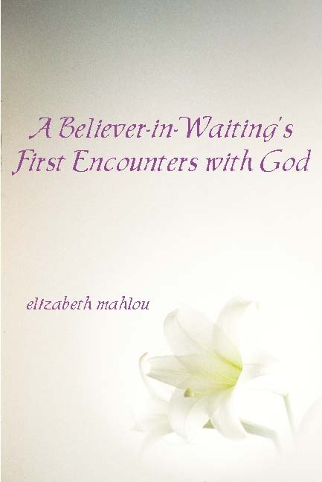
YOU ARE INVITED TO A BOOK COMING OUT PARTY.
When: Saturday, Aoctber 15, 2011; 12-4
Where: 175 Lang Street, San Juan Bautista
(Pick up possible: call 831-578-0290)
Note: A gift copy of the book will be available for each guest.

