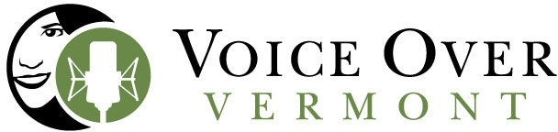

Audiobook Production Price List 2023

Author Narrations at Shelburne, VT Studio: $500 pfh
Author-at-home Narrations: $650 pfh *NEW in 2023!*
Professional Narration (we source the talent): $400-600 pfh
Need help uploading to Audiobook Platform? $100 flat fee
Referral Thank You to our publishing partners: $50 pfh

What does this include? Informational call with the author, manuscript preparation (with the author), coaching and direction during the recording process, recording, editing and mastering files to audiobook specs, ready to upload to designated platform.

*Author-at-home narrations will require purchase of studio quality microphone and headphones. We’ve got suggestions. (Budget $250 or so).

Mary Catherine Jones MCJones@VoiceOverVermont.com 802-373-7690 c

